DEFINTIONS
Greenhouse Gas - Greenhouse gases are gases in Earth's atmosphere that trap heat. They let sunlight pass through the atmosphere, but they prevent the heat that the sunlight brings from leaving the atmosphere. The main greenhouse gases are: Water vapor. Carbon dioxide. There are 4 main types of greenhouse gases - The main gases responsible for the greenhouse effect include carbon dioxide, methane, nitrous oxide, and water vapor (which all occur naturally), and fluorinated gases (which are synthetic).
Carbon Footprint - To address greenhouse gas emissions, an organization/company needs to understand how what they do generates greenhouse gas emissions and what they can do to minimize or reduce activities that generate greenhouse gases. To do that, an organization/company creates a “carbon footprint” which is an inventory of the direct and indirect activities that could generate greenhouse gases followed by the accumulated measurement of direct and indirect emissions of greenhouse gases from organization company activity.
The graphic on the following page show the difference simply – greenhouse gases are on the top and the components of a carbon footprint (activities generating the gases) is on the bottom. The picture is taken from the Greenhouse Gas Protocol, “Technical Guidance for Calculating Scope 3 Emissions” which does a good job graphically of depicting what is in the definitions above. The lower portion of the graphic shows a potential inventory of contributors for an organization/company which would be calculated in order to compile a “carbon footprint” or the total of carbon/greenhouse gas emissions for the company. Here is a key to the gases that are referenced at the top of the graphic along with the primary source of emissions:
- Carbon Dioxide (CO2) - Human activities such as the burning of oil, coal and gas, as well as deforestation are the primary cause of the increased carbon dioxide concentrations in the atmosphere.
- Methane(CH4) - six major sources of atmospheric methane: emission from anaerobic decomposition in (1) natural wetlands; (2) paddy rice fields; (3) emission from livestock production systems (including intrinsic fermentation and animal waste); (4) biomass burning (including forest fires, charcoal combustion, and firewood burning); (5) anaerobic decomposition of organic waste in landfills; and (6) fossil methane emission during the exploration and transport of fossil fuels.
- Nitrogen Dioxide(N2O) - Road traffic is the principal outdoor source of nitrogen dioxide. The most important indoor sources include tobacco smoke and gas-, wood-, oil-, kerosene- and coal-burning appliances such as stoves, ovens, space and water heaters and fireplaces, particularly unflued or poorly maintained appliances.
- Perfluorocarbon – PFC’s dielectric and the primary atmospheric sources are aluminum production and semiconductor manufacture.
- Hydrofluorocarbon – air conditioning and refrigeration- HFC’s. Fluorinated gases are used inside of products like refrigerators, air-conditioners, foams and aerosol cans. Emissions from these products are caused by gas leakage during the manufacturing process as well as throughout the product's life. Refrigeration and air conditioning account for 79% of the total atmospheric release of HFC’s
- Sulfur Hexafluoride – insulating windows and electrical insulation. SF6 is used in dielectric insulation of electrical equipment, thermal window insulation, medical imaging, surgical procedures, semiconductor processing, metal casting and audio equipment and in all of these applications gas escapes into the environment during handling (23,600 times more potent than CO2).
- Nitrogen Trifluoride – electronics etching - NF3 is used by the electronics industry in the manufacture of semiconductor (SC), photovoltaic cell, and flat-panel display devices

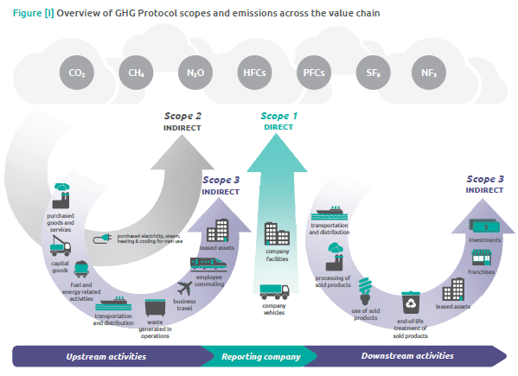

RESOURCES / TOOLS
- Greenhouse Gas Protocol is the accounting and reporting standard for GHGs. It is hard to digest but very detailed and informative. https://ghgprotocol.org/corporate-standard
  - Scope 1 are direct GHG emissions that occur from sources that are owned or controlled by your company. For example emissions from natural gas boilers, furnaces, or vehicles. Scope 2 accounts for emissions from the generation of purchased electricity consumed by your company. To learn more visit GHG Protocol and go to page 27.
  - Scope 3 is an optional reporting category and consists of indirect GHG emissions that are a consequence of company activities but occur from sources not owned or controlled by the company. Some examples of scope 3 activities are extraction and production of purchased materials; business travel, waste disposal, transportation of purchased fuels; and use of sold products and services. To learn more visit GHG Protocol and go to page 29 of the GHG Protocol report for Corporate Standards.
- EPA calculator and GHG Equivalencies is a great tool to help make sense of GHG
  - https://www3.epa.gov/carbon-footprint-calculator/
  - https://www.epa.gov/energy/greenhouse-gas-equivalencies-calculator
- The Cool Climate Network Tool is easy to play with and can get you a quick and easy estimation or an accurate one.
  - https://coolclimate.berkeley.edu/business-calculator

